Point de Vue

Food Security and Climate Change: The Role of Sustainable Intensification, the Importance of Scale and the CAP
Sean Rickard

A scientific consensus has developed that two of the most important issues of the 21st century are climate change and food security (IPCC, 2014). Agriculture is responsible for around 10 per cent of global greenhouse gas (GHG) emissions, though the impact increases markedly if deforestation is included. The challenge of reducing agriculture’s GHG emissions must be set alongside the food security concerns manifested in the step-change since 2006 to higher and more volatile agricultural prices. This reflects the world’s demand for food growing faster than its supply as the effects of an increasing global population and rising incomes in developing countries become manifest. Higher food prices, climate change and the depletion of the world’s natural capital form a trilemma that must be tackled simultaneously. While action on the demand side e.g., reduced food waste, could make an important contribution this article is focussed on the supply side and specifically it questions whether the EU agricultural industry’s structure is optimal for simultaneously delivering productivity growth while mitigating GHG emissions.

This article starts with the proposition that the only practical response to the trilemma is sustainable intensification (SI), defined here as any farming practice that … improves production without adverse ecological consequences … [is] … less vulnerable to shocks and stresses … [and contributes] … to the delivery and maintenance of a range of valued public goods, such as clean water [and] carbon sequestration (Royal Society, 2009, pp7). Drawing on this proposition this article argues that:
- SI necessitates an industry structure where larger scale, more capital intensive farms are prominent; and
- the Common Agricultural Policy (CAP) hinders this outcome.
What follows is divided into three sections. The first sets out why SI should be the primary management approach to meeting the joint challenges of food security and climate change. The second explains why SI and capital intensification at the farm level are complementary. The third outlines why the CAP’s system of direct payments is unlikely to deliver the level of investment and the mindset needed for successful SI.

Sustainable intensification and the joint challenges
Studies suggests that global agricultural output will need to rise by at least 70 per cent by 2050 (FAO, 2009) on the assumption that there will be no radical change in dietary preferences in developed countries and developing nations will continue along a trajectory of rising per capita consumption of meat and dairy products. On the supply side the natural resources that underpin agricultural production are being either physically or qualitatively depleted. To take three examples; the world’s arable area is gradually declining as land is converted to non-agricultural uses; the prices of fossil fuels and minerals have increased substantially as their stocks diminish; and the growing incidence of extreme weather is subjecting crops to greater stress and disease. To a greater or lesser extent these supply side trends are contributing to a slowing growth rate for grain yields – indeed in the EU cereal yields appear to have plateaued.

Set against these challenges, many question the need to increase food production arguing that lowering the level of meat consumption would solve the trilemma. It is indisputable that a significant reduction in the consumption of meat and dairy products in developed nations, accompanied by a marked scaling back in the aspirations of developing nations would reduce global agriculture’s consumption of natural resources and moderate GHG emissions. However, there is no agreement as to the required reduction in the consumption of meat and dairy products let alone the mechanism. A pragmatic assumption is that global demand for these foods will continue to rise implying that without a substantial increase in production global food prices – including EU prices – will tend to rise faster than in the past. This rules out, even in the EU, a general switch to low-input-low-output systems such as organic farming as this would result in a serious shortfall in the supply of food. Moreover, it is doubtful if the widespread adoption of such systems – involving flame weeding and the rotation of arable land and grass leys – would mitigate agriculture’s GHG emissions. When compared at the farm level organic crop yields are up to 34 per cent lower than for conventionally grown crops (Seufert, et al., 2012) and this implies the need for more arable land which in turn would necessitate deforestation with adverse effects for climate change.

A solution to the trilemma requires low-input-high-output systems. This is the essence of SI as defined above and in this respect is aligned with the FAO’s concept of climate smart agriculture. To be formally correct successful SI delivers a substantial rise in natural resource productivity (NRP) which is defined here conceptually as:
NRP =
where NRP growth records increases in output involving neither a proportional rise in the volumes of natural resources consumed nor a depletion in their quality. For example, if additional output is achieved by practices that increase GHG emissions this depletes, over the longer term, the climate’s ability to support production. The inclusion of non-market externalities in NRP will present measurement problems but as a concept it captures the essence of SI. From this perspective it would be timely for the economics profession to narrow its focus from the broader concept of total factor productivity (TFP) – and its heavy reliance on labour productivity – to NRP.

Sustainable intensification and capital intensity
The growth of NRP, as with TFP, is the product of a weighting of technological advance and gains in technical efficiency. It is reasonable to hypothesise that the technological advances underpinning NRP will be largely in the areas of biotechnology, information and engineering technology. Advances in plant breeding offer the prospect of the more efficient take-up of nutrients and climate adaption, while developments in livestock breeding are likely to deliver improvements in feed-conversions, health and immunology. Leading scientists (see for example Beddington, 2009) have argued that a second green revolution based on SI is feasible but all draw attention to the importance of both public and private investment in agricultural R&D.

Precision engineering – essentially the fusing of information and engineering technology – has the potential not only to deliver NRP growth in its own right but also to augment biotechnological advances. Experience shows that at the farm level actual performance falls below potential and in the case of NRP minimising the shortfall requires both enhanced technical efficiency e.g., human capital, including management expertise, and also the embedding of advances in engineering, information and building technologies in the farm’s capital stock. Farming in the EU has long displayed a trend towards larger scale and capital intensity and this trend is now being reinforced by precision technology. For both crops and livestock these technologies involves mixtures of remote sensing and scanning, data processing and the automation of operations. Although proponents argue that precision agriculture increases output – crop yields are sensitive to the timing and accuracy of input applications – its direct contribution to mitigating climate change results from the rise in NRP as fossil based resources are used more efficiently and minimum tillage systems sequestrate GHG emissions. Indirect mitigation is boosted if the growth of NRP is sufficient to release areas of land from agriculture thereby creating further scope for carbon sequestration. Adding buildings to the mix has the potential to deliver energy savings or the generation of renewable energy e.g., anaerobic digesters. Figure 1 summarises how the combination of technological advance and increasing technical efficiency contribute to NRP growth and climate change mitigation.

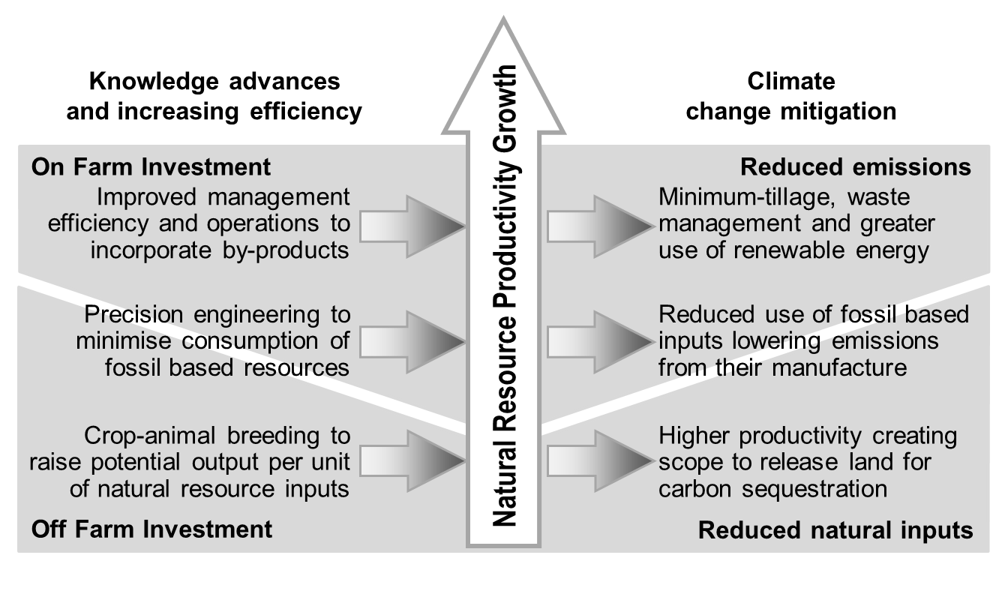
Figure 1: Natural resource productivity and climate change mitigation

Figure 1 shows schematically that delivering NRP growth is highly dependent on investment: off farm by plant and animal breeders as well as agricultural engineers; and on-farm by farmers. Investment in R&D by breeders and agricultural engineers is the mechanism for converting advances in knowledge into products and farming operations but it is only when these are adopted at the farm level that their benefits are captured. In the case of precision technologies adoption at the farm level involves not only sufficient expertise and a positive attitude towards innovation but also the ability to fund the necessary capital investment. Although precision farming has the potential to deliver significantly lower operating costs the investment costs involved in the transition to precision farming are lumpy and expensive and so take-up depends on a farm’s ability to purchase or lease expensive machinery (Schimmelpfennig and Ebel, 2011). In this respect, larger scale farms that are in a position to benefit from economies of scale would appear to have an inherent advantage: they are more likely to be profitable, have greater access to investment funds and also a larger volume of output over which to spread the cost. This accords with the technology adoption literature which shows the prominence of farm size and financial status when it comes to a willingness to invest in new technologies (e.g., Daberkow and Mc Bride, 2003) though other factors are also influential, notably the quality of the land and the education of the farmer.

This is not to suggest that smaller scale farms lacking investment funds cannot make contributions to mitigating climate change. But in the absence of capital investment the options are necessarily more limited and can involve a loss of profitability e.g., cover crops. Even the spreading of manure requires state-of-the art trailing machines and the application of injection methods in order to minimise emissions of gases such as methane and ammonia. Precision farming requires knowledge that goes beyond handling techniques and in particular requires an ability to accurately interpret the high volumes of data collected. That is, the adoption of technological advances that involve sophisticated engineering and information technologies demand higher levels of human capital; larger scale farms not only necessitate high levels of management but also they can spread the cost of specialised and highly educated labour over a larger output and are more likely to be in a position to fund training.

Capital intensity and the CAP
The foregoing implies that in the EU, larger scale farms offer greater potential than their smaller counterparts to satisfy the objectives of increasing production while minimising the use of natural resources and mitigating the industry’s contribution to climate change. Within the EU production is being concentrated on larger-scale farms but progress is slow. About 70 per cent of EU holdings have an area of less than five hectares and around half are defined as semi-subsistent (Davidova, 2014). In the absence of direct payments some 80 per cent of EU farms would not break-even and if direct payments are included in the farms’ revenue then this proportion only falls to 65 per cent (Commission, 2010). The growing average size of farm in the EU is evidence of the existence of economies of scale; indeed, the average value added per labour unit for the EU’s largest farm size group is more than ten times that for the smallest farms’ group (Commission, 2010).

Figure 2 is an attempt to illustrate schematically the relationship between scale i.e., units of output, and the scope to invest. In practice the situation is more complex; although all farm types are entitled to direct payments the bulk of the expenditure goes to field based farms and even on the smallest farms a small proportion generate revenues that cover total costs. But the evidence is clear, the larger the scale of farm the larger the proportion earning a profit. Semi-subsistent, small scale farms are very unlikely ever to be in a position to earn a reasonable living from their land and for such farms direct payments under the CAP serve only as income augmenting social payments; insufficient to generate a surplus to fund performance improving investment (Viaggi, et al., 2009). The investment advantage arising from economies of scale is likely to be reinforced by the economy of scope that is created when, for example, a scale invariant development to raise NRP e.g., crops bred to take up nutrients more efficiently is combined with a scale enhanced innovation e.g., precision technology (Fernandez-Cornejo, et al., 2001). The logic of Figure 2 is that the CAP’s direct payments slow, but cannot in the long run prevent the structure of EU agriculture evolving to an industry where the overwhelming bulk of production is generated by larger scale, capital intensive farms.

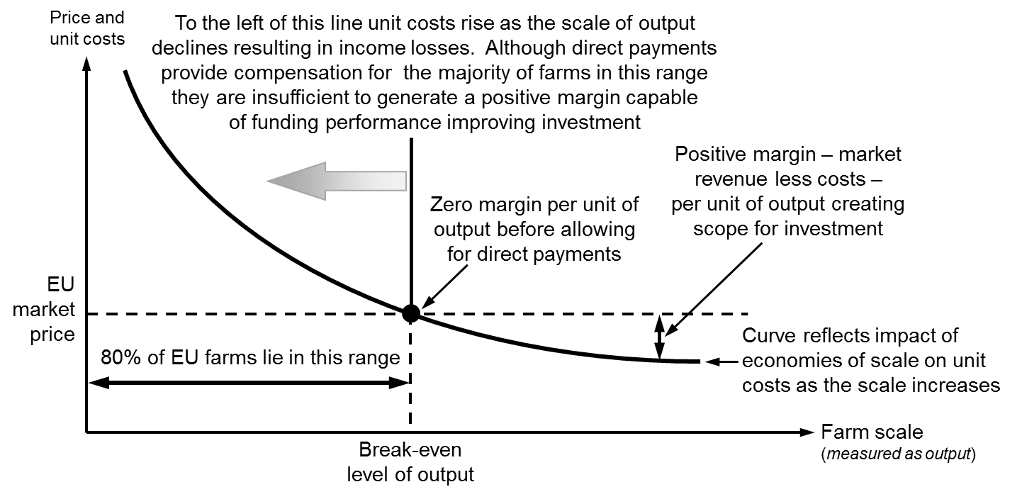
Figure: 2: Scale and the scope to invest

Larger scale farms can utilise their economic advantage to invest in precision technologies, smart buildings and renewable energies thereby contributing significantly to faster NRP growth and climate change mitigation. But at the current pace of change it will be many years before EU agriculture arrives at an optimum structure. One way to more rapidly achieve the necessary structural change would be to remove or rapidly phase out direct payments. Indeed, in a document published by the European Commission as part of its consultations prior to the 2013 reform of the CAP it acknowledged that following the phasing out of direct payments …. farms which will continue to be economically viable in the new environment will be larger, more open to innovation leading to cost optimisation, productivity growth and less labour-intensive (Commission, 2011, pp73). In rejecting this option the Commission implicitly confirmed that social considerations are primus inter pares but significantly it did not claim that the removal of direct payments would be followed by a fall in total agricultural output in the EU; an outcome supported by economic modelling. The CAP’s direct payments are not only in conflict with more rapid structural change but also they tend to create a defensive attitude on smaller scale, poorly performing farms where technological change is viewed as a threat rather than an opportunity (Viaggi, et al. 2009).

A step change required
The twin challenges of food security and the mitigation of climate change are more likely to be satisfactorily resolved if there is a step change in investment: off farm by breeders and agricultural engineers to embed new knowledge in products and operations; and on farm in fixed capital to efficiently apply the new sustainable farming operations. One effect of a decision to phase out direct payments would be the scope to divert considerable funds to public sector agricultural R&D. Another would be the signal to public and private research centres that in future the European farming industry would be more capable of investing in capital intensive, knowledge based solutions. Finally, the phasing out of direct payments would create scope for better targeted and funded, stand-alone environmental and rural policies. For example, environmental policies could enable carbon sequestration on non-productive land and rural economy policies would be freed to pursue objectives based on non-agricultural priorities.

Further Reading
Beddington, J., (2010), Food security: contributions from science to a new and greener revolution, Philosophical Transactions of the Royal Society B, 365, 61-71.
Commission, (2010), Developments in the income situation of the EU agricultural sector, Directorate-General for Agriculture and Rural Development, http://ec.europa.eu/agriculture/rica/pdf/hc0301_income.pdf
Commission, (2011), The Reform of the CAP towards 2020: Consultation Document for Impact Assessment, European Commission, Brussels. http://ec.europa.eu/agriculture/cap-post-2013/consultation/consultation-document_en.pdf
Daberkow, S. and McBride, W., (2003), Farm and Operator Characteristics Affecting the wareness and Adoption of Precision Agricultures in the US, Precision Agriculture, 4 (2), 163-177
Davidova, S., (2014), Small and Semi-subsistence Farms in the EU: Significance and Development Paths, EuroChoices, 13 (1), 5-9
FAO, (2009), Report of the FAO Expert Meeting on How to Feed the World in 2050, Rome, June. ftp://ftp.fao.org/docrep/fao/012/ak542e/ak542e19.pdf
Fernandez-Cornejo, J. Daberkow, S. and McBride, W. D., (2001), Decomposing the Size Effect on the Adoption of Innovations: Agrobiotechnology and Precision Agriculture, AgBioForum, (4) 2, 124-136.
IPCC, (2014), Climate change 2014: Impacts, Adaptation and Vulnerability. Chapter 7, Food security and food production systems, Contribution of working group II to the fourth assessment report of the intergovernmental panel on climate change, eds., J. R. Porter et al. Carnegie, Stamford, CA, March.
Royal Society, (2009), Reaping the benefits: science and the sustainable intensification of global agriculture, London, October.
Schimmelpfennig, D. and Ebel, R., (2011), On the Doorstep of the Information Age: Recent Adoption of Precision Agriculture, Economic Information Bulletin, No. 80, ERS, USDA.
Seufert, V., Ramankutty, N. and Foley, J. A., (2012), Comparing the yields of organic and conventional agriculture, Nature, 485, 229-234.
Viaggi, D., Raggi, M. and Gomez y Paloma, S., (2009), Facing decoupling: use of payments and investment reaction to decoupling in the EU, Paper presented at the IAAE Conference, Beijing, August.

Sean Rickard, Independent Economic Analysis, UK. Email: sean@seanrickardltd.co.uk

